IEC Symbol Detection using SAM-CLIP with Bounding Box Extraction

Objective:
The objective of this project is to:
- Detect IEC symbols from images
- Draw bounding boxes around detected symbols
- Extract individual symbols
- Use SAM (Segment Anything Model) for segmentation
- Use CLIP (Contrastive Language-Image Pretraining) for symbol classification

Method Used
This project uses SAM-CLIP hybrid approach
SAM (Segment Anything Model)
Used for:
- Detecting objects in image
- Creating segmentation masks
- Generating bounding boxes
CLIP Model
Used for:
- Understanding symbols
- Matching symbols with text prompts
- Filtering only IEC symbols

Libraries Used
Torch | -Deep learning model

OpenCV | -Image processing

NumPy | -Array operations

Matplotlib | -Visualization

SAM | -Segmentation

CLIP | -Symbol classification

Step-by-Step Code Explanation
Step 1 — Install Required Packages
!pip install torch torchvision torchaudio
!pip install opencv-python matplotlib pillow numpy
!pip install segment-anything
!pip install CLIP
This step installs:
- PyTorch for deep learning
- OpenCV for image processing
- Segment Anything Model
- CLIP Model

Step 2 — Load SAM Model
from segment_anything import sam_model_registry, SamAutomaticMaskGenerator
This imports:
- SAM model
- Mask generator

Load Checkpoint:
SAM_CHECKPOINT = "sam_vit_h_4b8939.pth"
SAM_TYPE = "vit_h"
Explanation
- vit_h = High accuracy model
- Checkpoint = pretrained weights

Load Model:
sam = sam_model_registry[SAM_TYPE](checkpoint=SAM_CHECKPOINT)
This loads the SAM model

Create Mask Generator
mask_generator = SamAutomaticMaskGenerator(
sam,
points_per_side=32,
pred_iou_thresh=0.86,
stability_score_thresh=0.92,
min_mask_region_area=100
)
points_per_side | -Number of sampling points

pred_iou_thresh | -Mask accuracy threshold

stability_score_thresh | -Stable masks only

min_mask_region_area | -Remove small noise

Step 3 — Load CLIP Model
import clip
clip_model, clip_preprocess = clip.load("ViT-B/32")
Explanation
CLIP is used to:
- Understand symbol meaning
- Filter IEC symbols

Step 4 — Load Image
image = cv2.imread(image_path)
This loads the input image.

Step 5 — Generate Masks
masks = mask_generator.generate(image)
Explanation
SAM generates:
- All possible objects
- Each object has:
  - mask
  - bounding box
  - score

Step 6 — Extract Bounding Boxes
for mask in masks:
bbox = mask['bbox']
Bounding Box Format
[x , y , width , height]

Step 7 — Draw Bounding Boxes
cv2.rectangle(image, (x,y),(x+w,y+h),(0,255,0),2)
Explanation
Draws rectangle around:
- IEC symbols
- Detected objects

Step 8 — Crop Symbols
symbol = image[y:y+h , x:x+w]
This extracts symbol inside bounding box.

Step 9 — CLIP Filtering
text = clip.tokenize(["IEC symbol"])
CLIP compares:
- image
- text
Returns best matching symbols.

Step 10 — Final Output
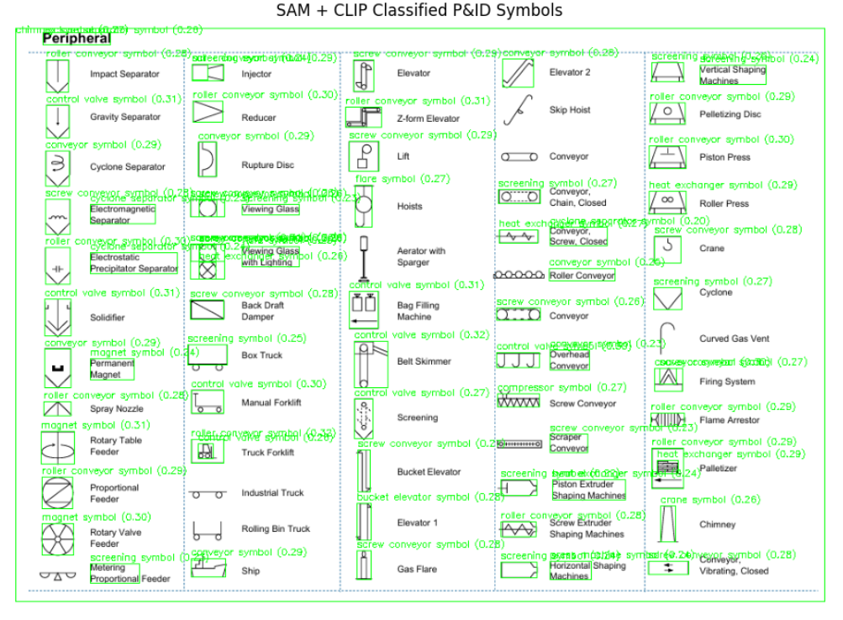

After extract any symbol:
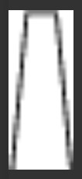
Limitations
- Blur during cropping
- Small symbol detection difficult
- Over segmentation sometimes

